ANTELOPE VALLEY FAIR

This past summer, our team reached out to the coordinators of our local county fair. We proposed an idea to have some of the FIRST teams in our valley get together and run a live display at the then upcoming fair. After several months of working with the other teams and the fair coordinators we had a arranged for a few teams to bring their robots to the fair on the weekends and demonstrate them in the community building.

On the first day, we arrived early to work with one of the fair coordinators, Susan Chaisson, to set up our area. We had been allotted a small area inside the community building about 10ft by 20ft surrounded on three sides by chairs. This was a relatively small area to demonstrate a robot but we made it work. Along with the FRC Team 2339 Robolopes, we entertained crowds of people introducing them to robotics and teaching them about engineering.

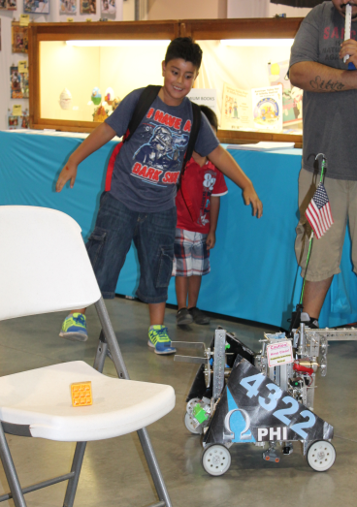 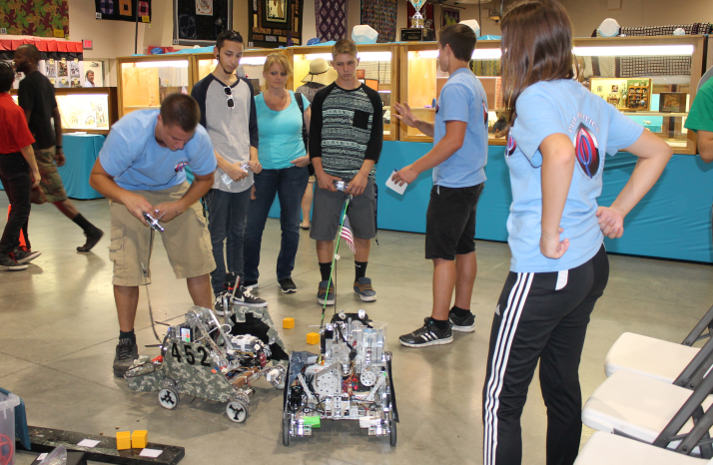

When Susan came back to check on us she said that there was a larger space in another part of the building that had just been cleared up for us. We then packed up our equipment and moved to the new location to continue demonstrating our robots. We also got to show some kids the internal workings of our robots.

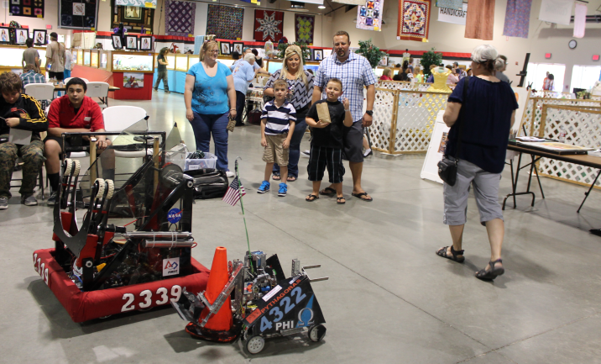 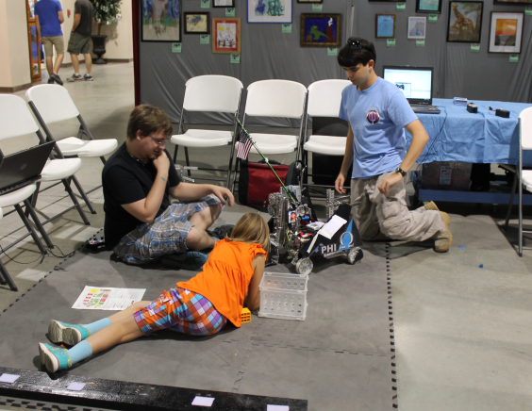

When we returned the next weekend we were greeted with a surprise. Susan had talked to the rest of the fair board and they were so impressed at our success the previous weekend that they had given us the entire front patio of the community building to present our robots. With the extra space, we called in another FTC team, 5011 Bot Squad, and another FRC team, 5012 Griffin Gear. Our new location was right next to the front gate through which hundreds of people passed each hour. We also could now be more interactive with our audience by dropping our Star Trek Tribbles into their hands with our robot.

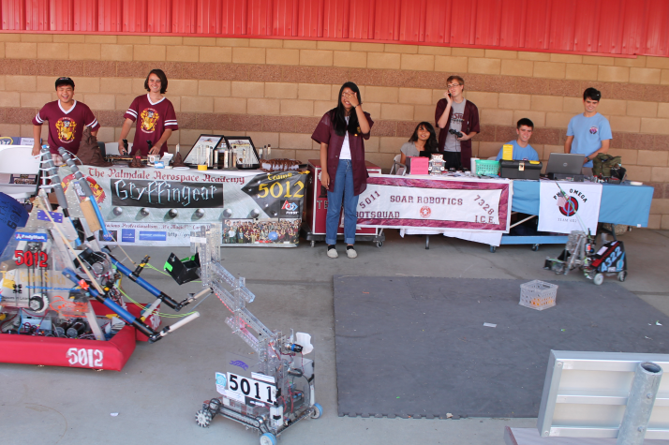 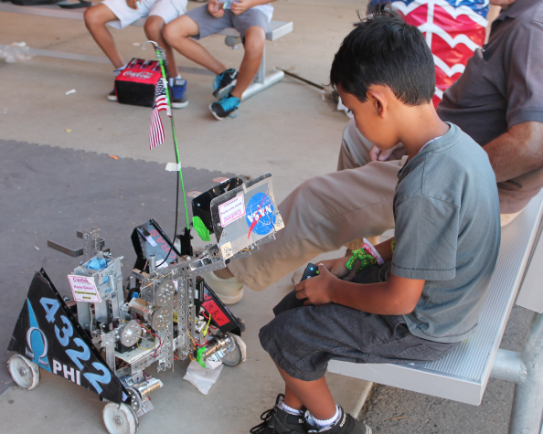

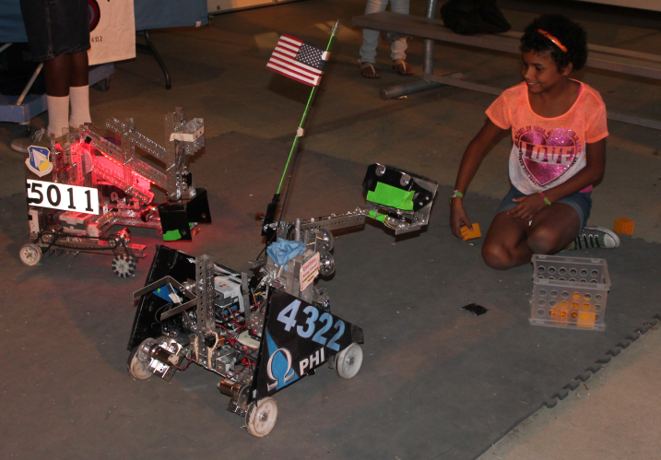 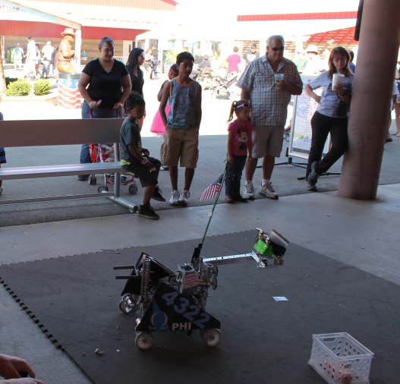

By the end of the fair we had handed out Tribbles and fliers to several hundred people and had encouraged several families to become involved in FIRST. The fair organizers where so impressed at our performance that they have invited us to come back again next year and they even promised us some display cases for a static display. The Antelope Valley Fair outreach has been by far our most successful and impacting outreach.